5.69: Forces on the hammer:
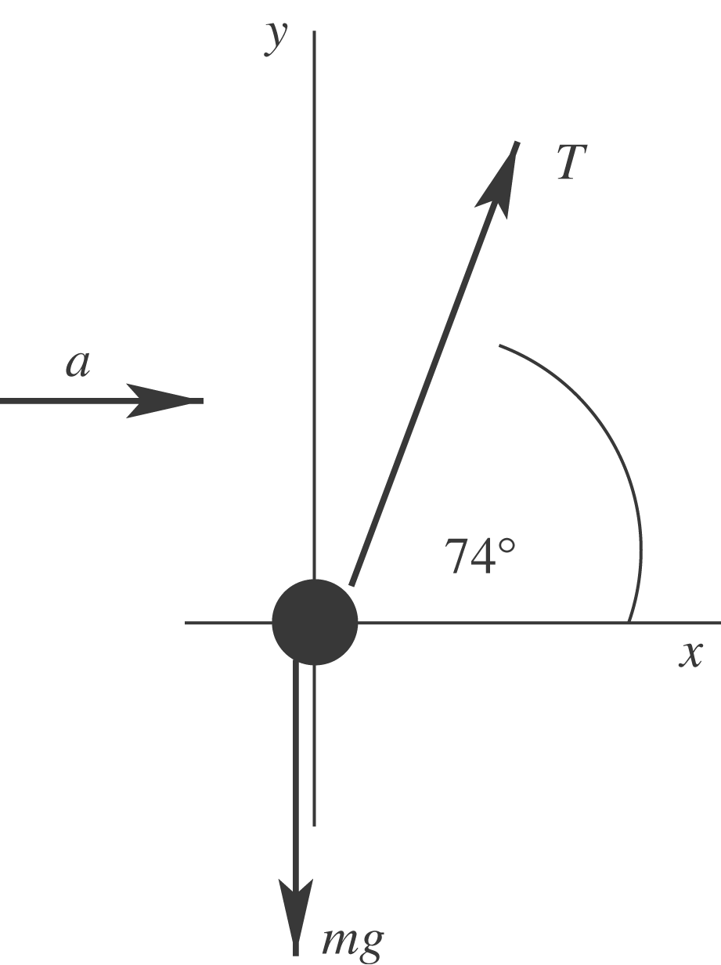

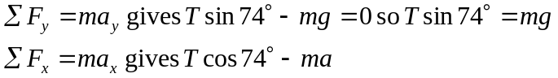
Divide the second equation by the first:
